BRAIN SMART
SEMINAR
Are You Struggling with?
Anger
Brain injury
Learning Challenges
Attention problems
Poor thinking and cognition
School work difficulties
Feeling like giving up
Hopelessness
Ineffective concentration
Getting upset easily
Loss of hope
Up and down moods
Worry too much
Stress
Rage
Fearfulness
Unhealthy behaviors
Trauma

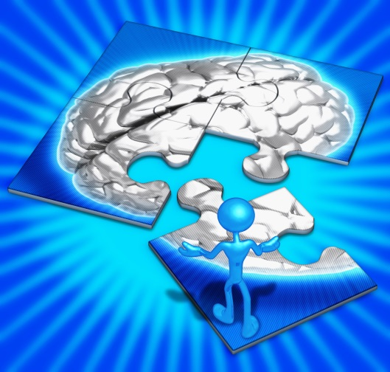
You will learn How to Effectively Support and Enhance
- Brain Functioning in Seniors, Adults, Teens, and Children
- Calm Tensions
- Improve Cognition
- Stress Release
- Improve Concentration
- Lift Moods
- Better Outlook on life
- Strengthen Mental Functions
- Mental Stability
- Overall Brain Health
Brain Smart Seminar is for you!

● How 100,000 people in over 100 countries have witnessed amazing life-changing results.
● How to provide essential nutritional support to the brain and the central nervous system.
●Most researched and published micro nutrient in history being proven in Science, in Court and in Practice.

Speaker:
Corinne Allen Ph.D.
When: May 1, 2014, Thurs, 7:00pm-10:00 pm
Where: Best Western Inn 506 W Appleway Ave,
Coeur d'Alene, ID 83814
Hotel only (800) 780-7234 , rooms special rates
To register, call:
866-81-Brain
or email
brainadvance@gmail.com
$20.00 if registered before April 30th, $30.00 if register at the door
The first 20 to register will receive a free gift to help the brain valued at $25.00
Call or Email today: seating limited.

